Instructions for reading and replying to secure communications from the Legal Aid Board

When you open an encrypted email from a legalaidboard.ie address you will see the following message

The first thing you must do is save the securedoc.html attachment to an accessible location i.e. your desktop.

When the file has been saved and opened you will see one of two screens depending on whether or not you are a first time user.

Existing User Screen

First Time User Screen

If you are an existing user enter your password and click the OPEN button and the encrypted email will be displayed. However, if you are a first time user you will have to register your details. To do this click the REGISTER button and complete the New User Registration form.

Once the registration form has been completed you must activate your account.

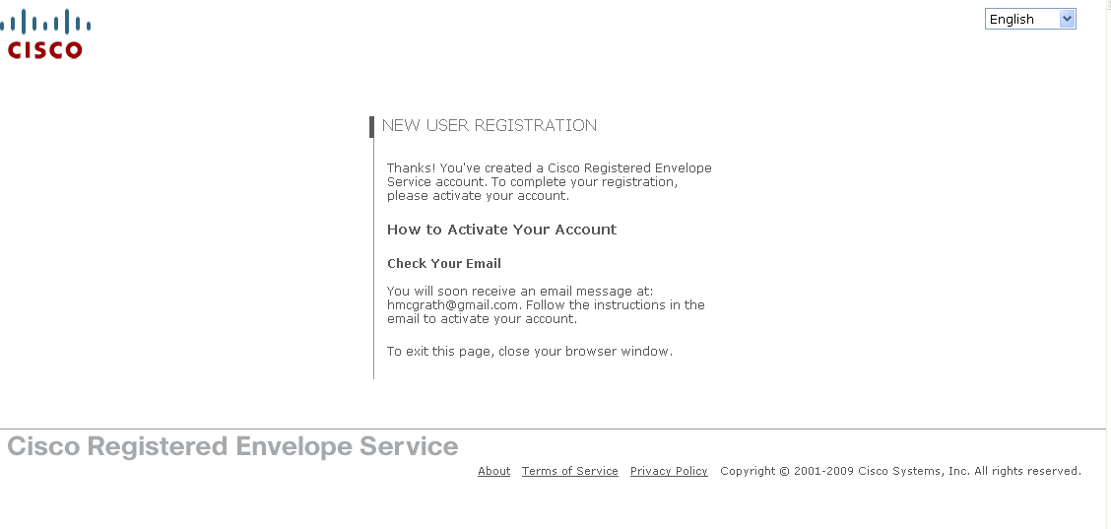
To do this, return to your Inbox and wait for an activation email from DoNotReply@res.cisco.com. Open the email and click on the blue ‘Click here to activate this account’ link.

When your account has been activated return to the Cisco Registered Envelope Service page. If you have closed this page you can reopen it by double clicking the securedoc.html file you saved earlier.

Enter your password and click the OPEN button and the encrypted email will be displayed.

